Usage/Spend Analysis

Activity <Insert Project Title>

Description < List of tables to be used in usage and spend analysis >

<Document sub-title or date>

Version Control

|  |  |  |  |
| --- | --- | --- | --- |
| Version | Description of Change | Author | Date |
|  |  |  |  |
|  |  |  |  |
|  |  |  |  |

GUIDANCE on completing this document

(delete this section prior to submitting document for approval)

This document should be completed to the level of detail which is appropriate for the size of spend and risk of the product/service to be purchased.

The template should be adapted as required.

Guidance is provided in italics throughout the document and should be deleted in the final version. For additional advice or support in completing this document, contact XXXXX.

Table of Contents

1. Procurement Project Details Subject to the Supply Market Analysis 3

2. Total Addressable spend 3

3. Total spend by supplier 3

4. Spend by department 4

5. Total and average value of transactions 4

6. Transactions by department 5

7. Type of transactions 5

Update the table of contents last – after all feedback is incorporated and formatting finalised. To do this, left click in the table, then right click and select ‘Update Field’.

1. Procurement Project Details Subject to the Usage / Spend Analysis

|  |  |
| --- | --- |
|  | |
| Sourcing Activity | Insert procurement project name |
| RFx Number | Insert procurement project number |
| Requirements Overview | Provide a brief overview of the requirements |
| Procurement Objectives | Provide a brief overview of the objectives |

1. Total Addressable spend

Calculate the total addressable spend for the category/project. Remove elements that cannot be influenced (e.g. regulatory fees, inter department transfers). Identify any trends and seasonality in the spend.

Example table

1. Total spend by supplier

Identify the top suppliers and the spend as shown in the example below. This allows analysis of the concentration of spend among the suppliers. A diverse range of suppliers may indicate opportunities for aggregation or consolidation. It may also mean a large amount of ‘maverick’ spend that is not currently contracted.

Example table

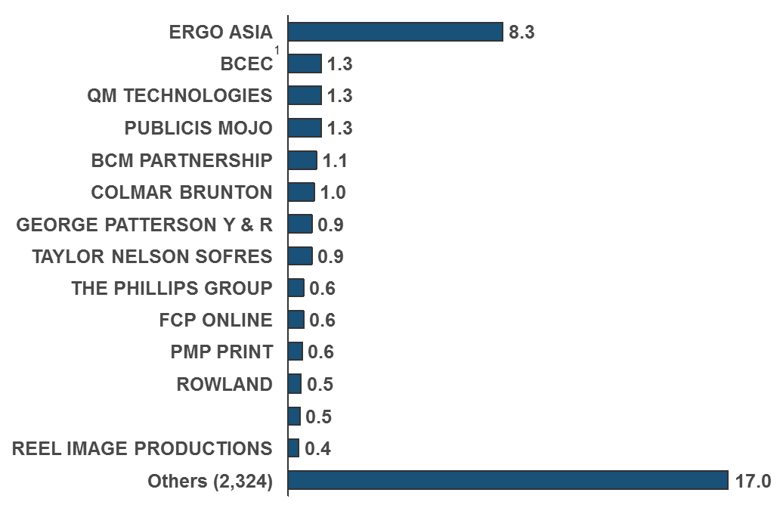

[Enter Text]

1. Spend by department

Identify the spend by department. This helps identify some of the key stakeholders who may be impacted by any changes to supply arrangements. In addition it enables the practitioner to identify stakeholders to gather any specific requirements.

[Enter Text]

1. Total and average value of transactions

Identify the total number of transactions and calculate the average value of transaction for the addressable spend. This enables insight when used with other spend data to identify patterns within departments and potential improvements in purchasing channels (depending on the type of transactions)

1. Transactions by department

Identify the number and percentage of transactions by department. This will give insight to the purchasing patterns within departments and identify the size of purchases.

[Enter Text]

1. Type of transactions

Identify the type of transactions being used for payment. This data will enable insight to opportunities to improve purchasing behaviour and or payment processes with suppliers. As an example a high number of transactions without purchase orders may lead to identifying spend not under contract or process efficiencies for a specific department.